**--A. Customer Nodes Exploration**

***-- 1 How many unique nodes are there on the Data Bank system?***

SELECT COUNT(DISTINCT node_id) AS unique_nodes

FROM customer_nodes;

**RESULT:**

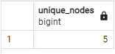

***-- 2 What is the number of nodes* *per region?***

SELECT r.region_name,COUNT(DISTINCT cn.node_id)

FROM customer_nodes cn JOIN regions r

USING(region_id)

GROUP BY r.region_name

ORDER BY r.region_name;

**RESULT:**

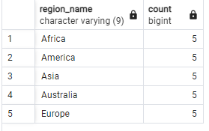

***-- 3 How many customers are allocated to each region?***

SELECT r.region_name,COUNT(DISTINCT cn.node_id)

FROM customer_nodes cn JOIN regions r

USING(region_id)

GROUP BY r.region_name

ORDER BY r.region_name;

**RESULT:**

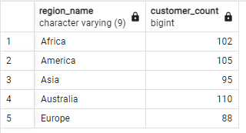

***-- 4 How many days on average are customers reallocated to a different node?***

WITH DAYS_IN_NODE AS (

SELECT

customer_id,

node_id,

SUM(DATEDIFF('days',start_date,end_date)) as days_in_node

FROM customer_nodes

WHERE end_date <> '9999-12-31'

GROUP BY customer_id,

node_id

)

SELECT

ROUND(AVG(days_in_node),0) as average_days_in_node

FROM DAYS_IN_NODE;

**RESULT:**

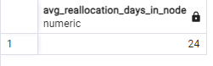

***-- 5 What is the median, 80th and 95th percentile for this same reallocation days metric for each region?***

WITH reallocation_days_cte AS

(

SELECT

cn.region_id,

r.region_name,

cn.customer_id,

cn.node_id,

SUM(cn.end_date-cn.start_date) AS reallocation_days

FROM customer_nodes cn

JOIN regions r

USING(region_id)

WHERE end_date <> '9999-12-31'

GROUP BY

cn.region_id,r.region_name,

cn.customer_id,

cn.node_id

)

SELECT

region_name,

ROUND(PERCENTILE_CONT(0.5) WITHIN GROUP (ORDER BY reallocation_days)) AS median_days,

ROUND(PERCENTILE_CONT(0.8) WITHIN GROUP (ORDER BY reallocation_days)) AS percentile_80_days,

ROUND(PERCENTILE_CONT(0.95) WITHIN GROUP (ORDER BY reallocation_days)) AS percentile_95_days

FROM

reallocation_days_cte

GROUP BY region_name

ORDER BY region_name;

**RESULT:**

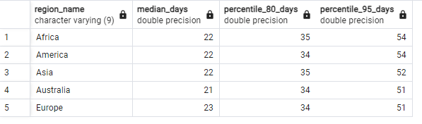

**--B. Customer Transactions**

***1 What is the unique count and total amount for each transaction type?***

SELECT

DISTINCT(txn_type) AS transaction_type,

COUNT(*) AS unique_transaction_count,

SUM(txn_amount) AS total_amount

FROM customer_transactions

GROUP BY transaction_type

ORDER BY transaction_type;

**RESULT:**

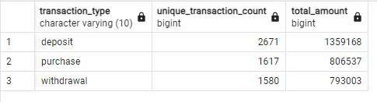

***-- 2 What is the average total historical deposit counts and amounts for all customers?***

WITH CTE AS (

SELECT

customer_id,

AVG(txn_amount) as avg_deposit,

COUNT(*) as transaction_count

FROM customer_transactions

WHERE txn_type = 'deposit'

GROUP BY customer_id

)

SELECT

ROUND(AVG(avg_deposit),2) as avg_deposit_amount,

ROUND(AVG(transaction_count),0) as avg_transactions

FROM CTE;

**RESULT:**

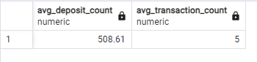

***-- 3 For each month - how many Data Bank customers make more than 1 deposit and either 1 purchase or 1 withdrawal in a single month?***

WITH customer_monthly_transactions AS (

SELECT

customer_id,

EXTRACT(YEAR FROM txn_date) AS txn_year,

EXTRACT(MONTH FROM txn_date) AS txn_month,

SUM(CASE WHEN txn_type = 'deposit' THEN 1 ELSE 0 END) AS deposit_count,

SUM(CASE WHEN txn_type = 'purchase' THEN 1 ELSE 0 END) AS purchase_count,

SUM(CASE WHEN txn_type = 'withdrawal' THEN 1 ELSE 0 END) AS withdrawal_count

FROM

customer_transactions

GROUP BY

customer_id, EXTRACT(YEAR FROM txn_date), EXTRACT(MONTH FROM txn_date)

)

-- Filter customers who meet the criteria

SELECT

txn_year,

txn_month,

COUNT(DISTINCT customer_id) AS customer_count

FROM

customer_monthly_transactions

WHERE

deposit_count > 1

AND (purchase_count >= 1 OR withdrawal_count >= 1)

GROUP BY

txn_year, txn_month

ORDER BY

txn_year, txn_month;

**RESULT:**

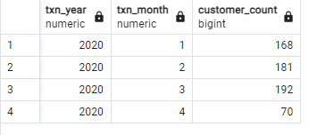

***-- 4 What is the closing balance for each customer at the end of the month?***

WITH cust_monthly_trans AS (

SELECT

customer_id,

EXTRACT(YEAR FROM txn_date) AS txn_yr,

EXTRACT(MONTH FROM txn_date) AS txn_month,

TO_CHAR(txn_date, 'Month') AS txn_month_name,

SUM(CASE

WHEN txn_type = 'deposit' THEN txn_amount

WHEN txn_type = 'withdrawal' THEN -txn_amount

ELSE 0

END) AS monthly_balance

FROM

customer_transactions

GROUP BY

customer_id, EXTRACT(YEAR FROM txn_date), EXTRACT(MONTH FROM txn_date), TO_CHAR(txn_date, 'Month')

),

running_balance AS

(

SELECT customer_id,

txn_yr,

txn_month,

txn_month_name,

SUM(monthly_balance) OVER(PARTITION BY customer_id

ORDER BY txn_yr,txn_month

ROWS BETWEEN UNBOUNDED PRECEDING AND CURRENT ROW

) AS closing_balance

FROM cust_monthly_trans

)

SELECT

customer_id,

txn_yr,

txn_month,

txn_month_name,

closing_balance

FROM running_balance

ORDER BY

customer_id,

txn_yr,

txn_month,

txn_month_name;

**RESULT:**

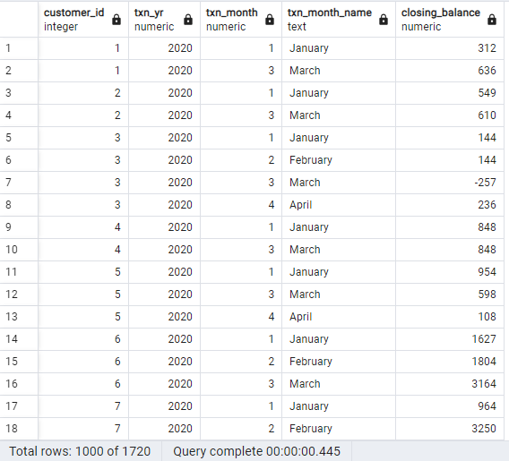

**--SOL2:**

WITH monthly_transactions AS (

SELECT

customer_id,

DATE_TRUNC('month', txn_date) AS txn_month,

TO_CHAR(txn_date, 'Month') AS month_name,

SUM(

CASE

WHEN txn_type = 'deposit' THEN txn_amount

WHEN txn_type = 'withdrawal' THEN -txn_amount

ELSE 0 -- Handle other transaction types as needed

END

) AS net_change

FROM

customer_transactions

GROUP BY

customer_id,

DATE_TRUNC('month', txn_date),

TO_CHAR(txn_date, 'Month')

),

cumulative_balances AS (

SELECT

customer_id,

txn_month,

month_name,

net_change,

SUM(net_change) OVER (

PARTITION BY customer_id

ORDER BY txn_month

ROWS BETWEEN UNBOUNDED PRECEDING AND CURRENT ROW

) AS closing_balance

FROM

monthly_transactions

)

SELECT

customer_id,

TO_CHAR(txn_month + INTERVAL '1 month' - INTERVAL '1 day', 'YYYY-MM-DD') AS end_of_month,

closing_balance

FROM

cumulative_balances

ORDER BY

customer_id,

txn_month;

**RESULT:**

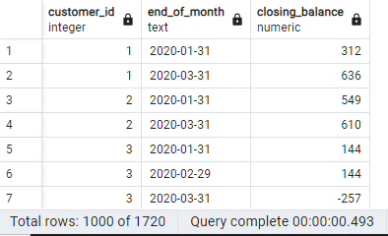

***- 5 What is the percentage of customers who increase their closing balance by more than 5%?***

WITH monthly_balances AS (

-- Step 1: Get closing balances for each customer at the end of each month

SELECT

customer_id,

DATE_TRUNC('month', txn_date) AS txn_month,

SUM(

CASE

WHEN txn_type = 'deposit' THEN txn_amount

WHEN txn_type = 'withdrawal' THEN -txn_amount

ELSE 0

END

) AS closing_balance

FROM

customer_transactions

GROUP BY

customer_id,

DATE_TRUNC('month', txn_date)

ORDER BY

customer_id,

DATE_TRUNC('month', txn_date)

),

balance_changes AS (

-- Step 2: Calculate the percentage change in balance compared to the previous month

SELECT

customer_id,

txn_month,

closing_balance,

LAG(closing_balance) OVER (PARTITION BY customer_id ORDER BY txn_month) AS previous_balance,

CASE

WHEN LAG(closing_balance) OVER (PARTITION BY customer_id ORDER BY txn_month) > 0

THEN (closing_balance - LAG(closing_balance) OVER (PARTITION BY customer_id ORDER BY txn_month)) / LAG(closing_balance) OVER (PARTITION BY customer_id ORDER BY txn_month) * 100

ELSE NULL -- Handle cases where the previous balance is 0 or doesn't exist

END AS percentage_change

FROM

monthly_balances

),

customers_with_increase AS (

-- Step 3: Identify customers whose closing balance increased by more than 5%

SELECT

customer_id

FROM

balance_changes

WHERE

percentage_change > 5

GROUP BY

customer_id

),

total_customers AS (

-- Step 4: Count total distinct customers

SELECT

COUNT(DISTINCT customer_id) AS total_customer_count

FROM

customer_transactions

)

-- Step 5: Calculate the percentage of customers who increased their balance by more than 5%

SELECT

ROUND( COUNT(DISTINCT cwi.customer_id) * 100.0 / tc.total_customer_count,2) AS percentage_increased

FROM

customers_with_increase cwi,

total_customers tc

GROUP BY

tc.total_customer_count;

**RESULT:**

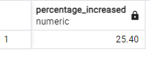

**--C. Data Allocation Challenge**

/*To test out a few different hypotheses - the Data Bank team wants to run an experiment where different groups of customers would be allocated data using 3 different options:

Option 1: data is allocated based off the amount of money at the end of the previous month

Option 2: data is allocated on the average amount of money kept in the account in the previous 30 days

Option 3: data is updated real-time

For this multi-part challenge question - you have been requested to generate the following data elements to help the Data Bank team estimate how much data will need to be provisioned for each option:

running customer balance column that includes the impact each transaction

customer balance at the end of each month

minimum, average and maximum values of the running balance for each customer

Using all of the data available - how much data would have been required for each option on a monthly basis?

*/

/*

1. Running Customer Balance (Impact of Each Transaction)

We will calculate a running balance that reflects the impact of each transaction on the customer's account.

2. Customer Balance at the End of Each Month

For Option 1, we need to calculate the customer balance at the end of each month, which will help allocate data based on this balance for the next month.

3. Minimum, Average, and Maximum Running Balance for Each Customer

For Option 2 (average balance over the last 30 days) and for understanding trends (Option 3), we will compute the minimum, average, and maximum running balance for each customer.

*/

-- ***Step 1:Calculate the Running Balance for Each Customer***

--We first calculate the running balance based on the transactions (deposits and withdrawals) for each customer.

WITH running_balances AS (

SELECT

customer_id,

txn_date,

SUM(

CASE

WHEN txn_type = 'deposit' THEN txn_amount

WHEN txn_type = 'withdrawal' THEN -txn_amount

ELSE 0

END

) OVER (PARTITION BY customer_id ORDER BY txn_date) AS running_balance

FROM

customer_transactions

)

**RESULT:**

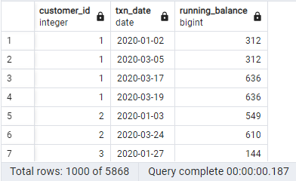

***--(Option 1)***

***-- Step 2:Calculate the Customer Balance at the End of Each Month***

--For Option 1, we will use the customer balance at the end of each month.

--The LAG function is used to get the previous month's balance.

WITH end_of_month_balances AS (

SELECT

customer_id,

DATE_TRUNC('month', txn_date) AS txn_month,

SUM(

CASE

WHEN txn_type = 'deposit' THEN txn_amount

WHEN txn_type = 'withdrawal' THEN -txn_amount

ELSE 0

END

) AS monthly_balance,

ROW_NUMBER() OVER (PARTITION BY customer_id, DATE_TRUNC('month', txn_date) ORDER BY txn_date DESC) AS rn

FROM

customer_transactions

GROUP BY

customer_id,

DATE_TRUNC('month', txn_date),

txn_date

)

SELECT

customer_id,

txn_month,

LAG(monthly_balance) OVER (PARTITION BY customer_id ORDER BY txn_month) AS data_allocated_for_next_month

FROM

end_of_month_balances

WHERE

rn = 1;

**RESULT:**

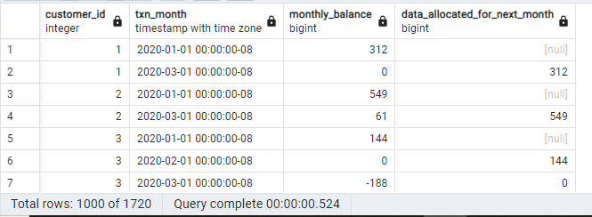

-- ***(Option 2)***

***--Step 3: Calculate Minimum, Average, and Maximum Running Balances***

--For Option 2, where the allocation is based on the average balance over the previous 30 days,

--we calculate the min, max, and average running balances.

WITH running_balances AS (

SELECT

customer_id,

txn_date,

SUM(

CASE

WHEN txn_type = 'deposit' THEN txn_amount

WHEN txn_type = 'withdrawal' THEN -txn_amount

ELSE 0

END

) OVER (PARTITION BY customer_id ORDER BY txn_date) AS running_balance

FROM

customer_transactions

)

SELECT

customer_id,

MIN(running_balance) AS min_balance,

AVG(running_balance) AS avg_balance,

MAX(running_balance) AS max_balance

FROM

running_balances

GROUP BY

customer_id;

**RESULT:**

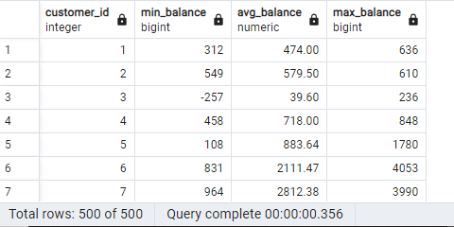

***--(Option 3)***

***--Step 4: Calculate Real-Time Balance***

--For Option 3, we need the total real-time running balance per day.

WITH daily_balances AS (

SELECT

customer_id,

txn_date,

SUM(

CASE

WHEN txn_type = 'deposit' THEN txn_amount

WHEN txn_type = 'withdrawal' THEN -txn_amount

ELSE 0

END

) OVER (PARTITION BY customer_id ORDER BY txn_date) AS running_balance

FROM

customer_transactions

)

SELECT

customer_id,

DATE_TRUNC('month', txn_date) AS txn_month,

SUM(running_balance) AS total_real_time_balance

FROM

daily_balances

GROUP BY

customer_id,

DATE_TRUNC('month', txn_date);

**RESULT:**

